**Assignment-1**

# **AWS Account Creation and Budget Configuration: Step-by-Step Instructions**

## **Part 1: Creating an AWS Account**

1. **Visit AWS Free Tier Webpage:**
   * Open a browser and navigate to the [**AWS Free Tier page**.](https://aws.amazon.com/free/)
   * Click **Create a Free Account**.

## **Provide Account Details:**

* + Enter an email address that has not been registered with AWS before.
  + Create a secure password and confirm it.
  + Assign an AWS account name (this can be changed later).

## **Choose Account Type:**

* + Select the account type as Personal (for demonstration purposes).
  + Fill in personal details such as name, address, phone number, state, and city.
  + Accept the terms and conditions, then click Create Account and Continue.

## **Provide Payment Information:**

* + Enter valid credit card details (credit cards like Visa, Mastercard, and others are accepted; RuPay cards may not work).
  + Note: A minimal verification charge may appear, which is refundable.

## **Activate the Free Tier Account:**

* + Complete all the steps to activate your **AWS Free Tier** account.
  + Log in to the AWS Management Console using your email and password.

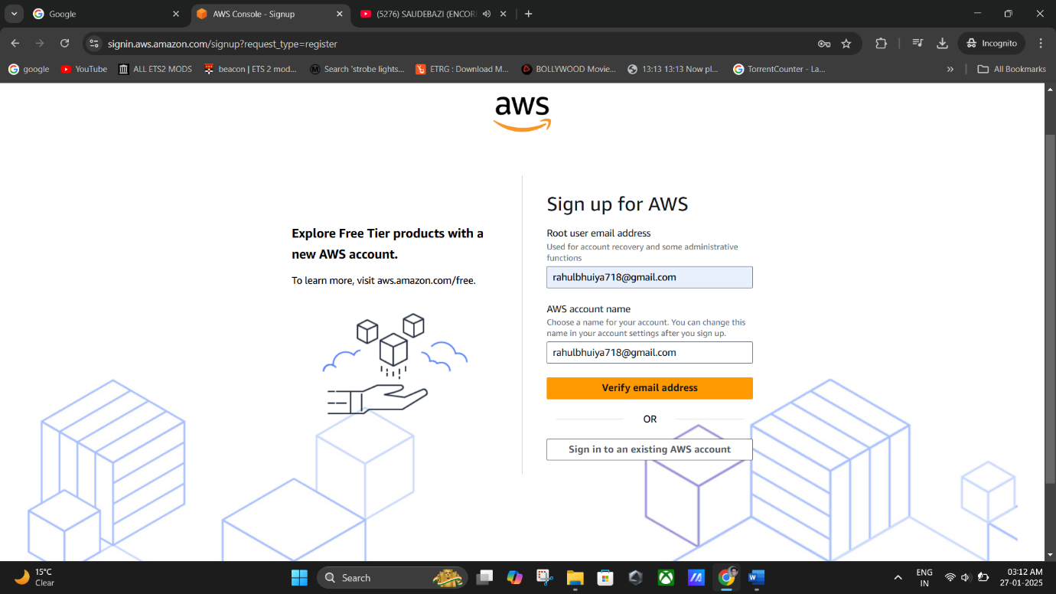

**(Create a Free AWS Account).**

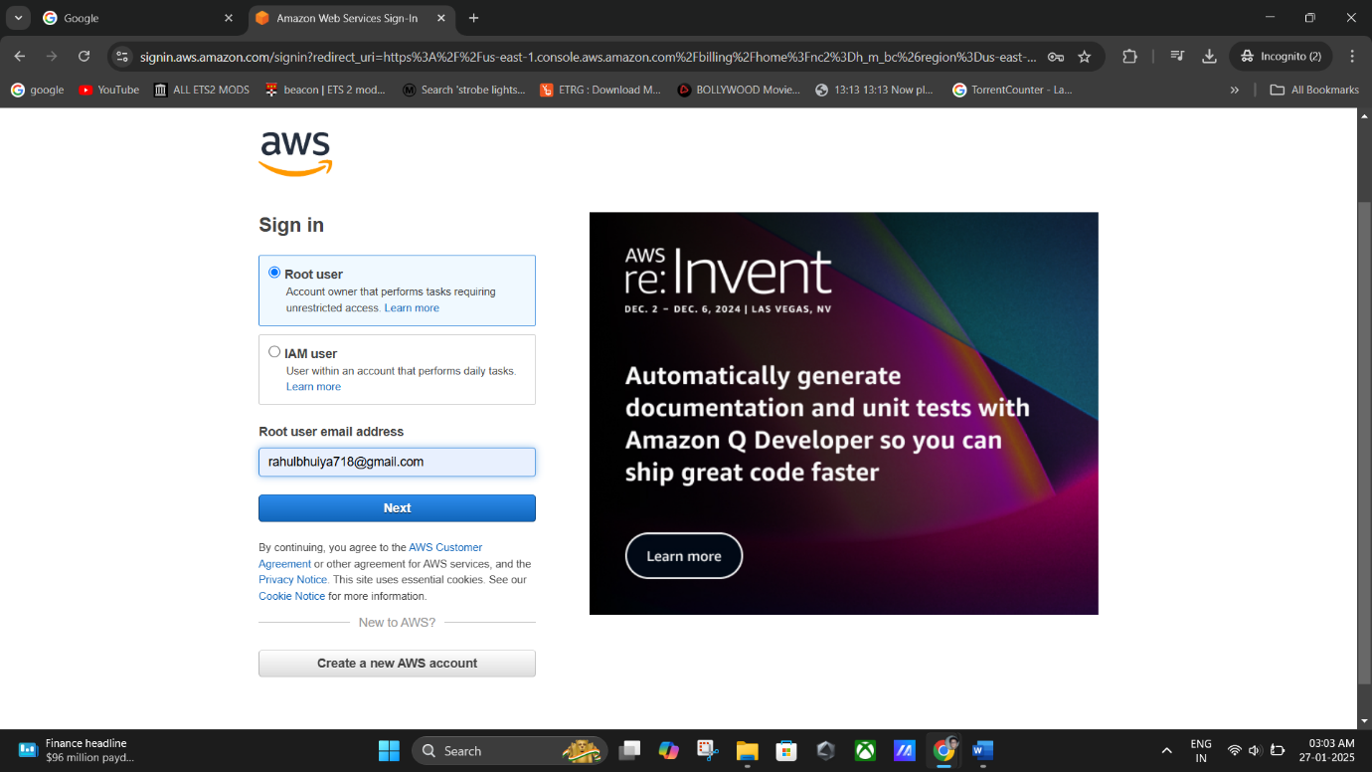

**(Sign in As Root User).**

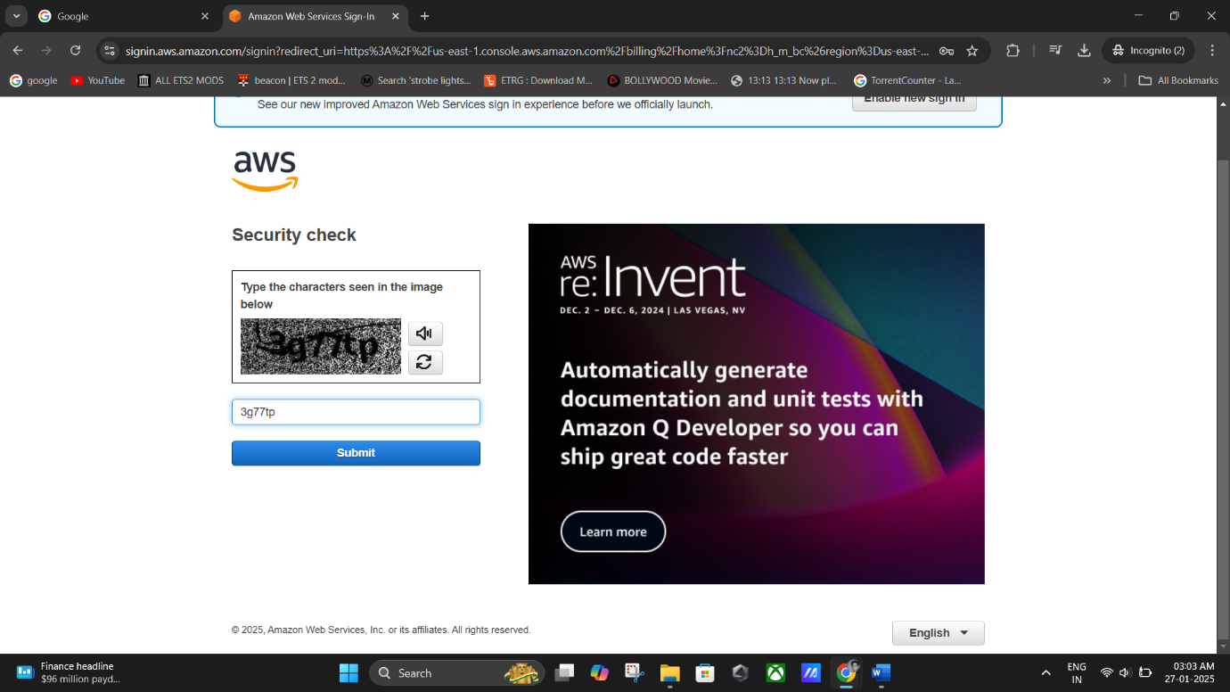

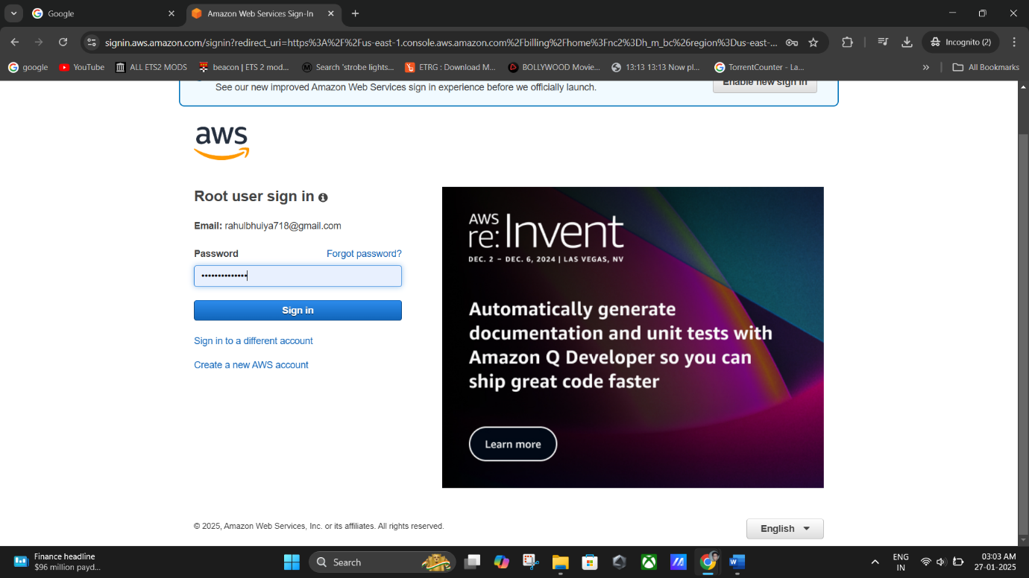

**(Sign in successfully).**

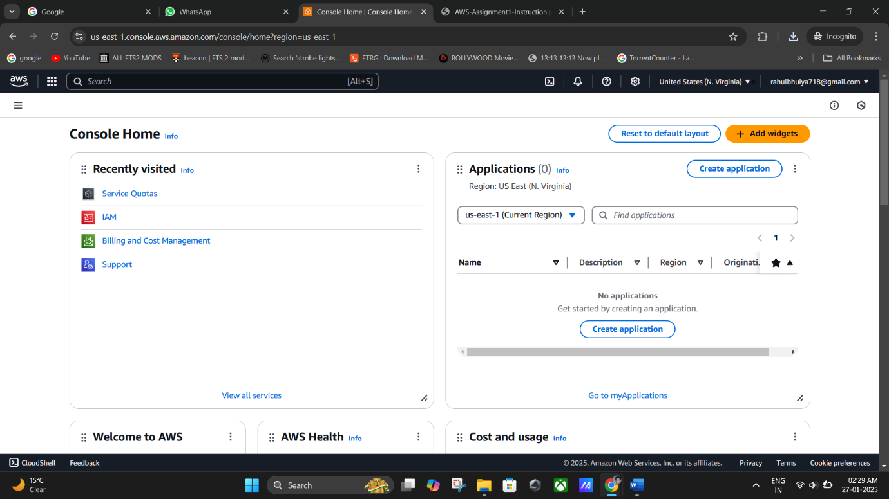

**(Welcome To AWS main Console).**

## **Remarks:**

* Double-check the email address and payment details for accuracy.
* Ensure you monitor any potential charges post the free tier period.

## **Part 2: Configuring a Budget in AWS**

1. **Sign in to the AWS Management Console:**
   * Use your AWS account credentials to log in.

## **Navigate to Cost Management:**

* + Click your **Account Name** in the navigation bar and select **Billing Dashboard**.

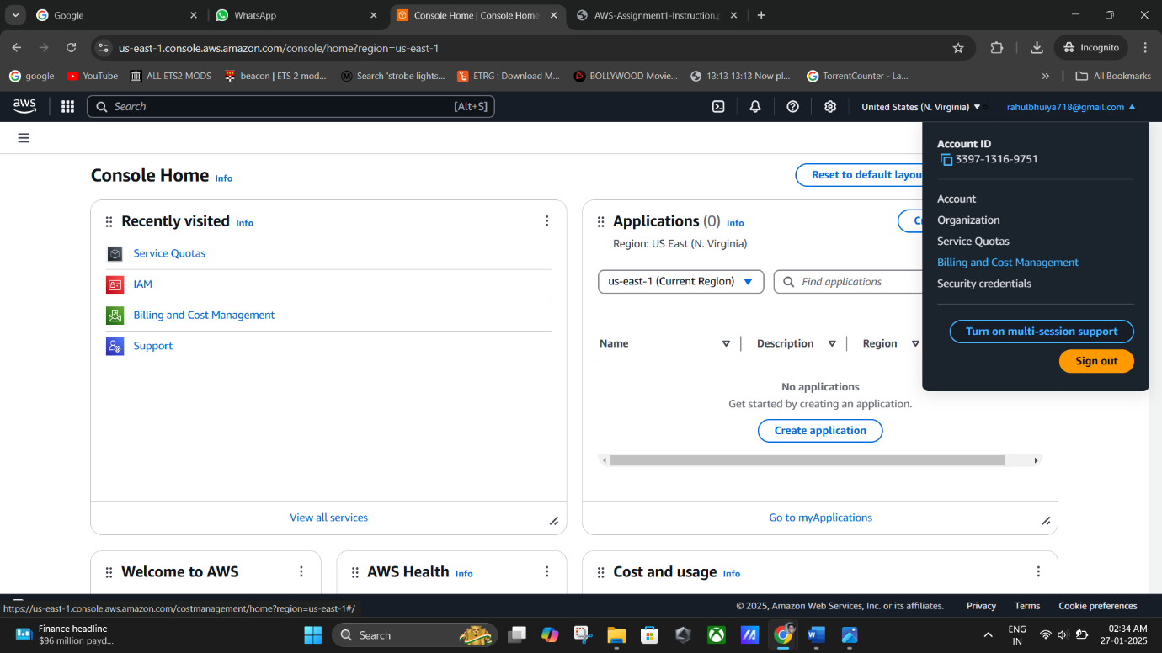

* Under **Cost Management**, choose **Budgets**.

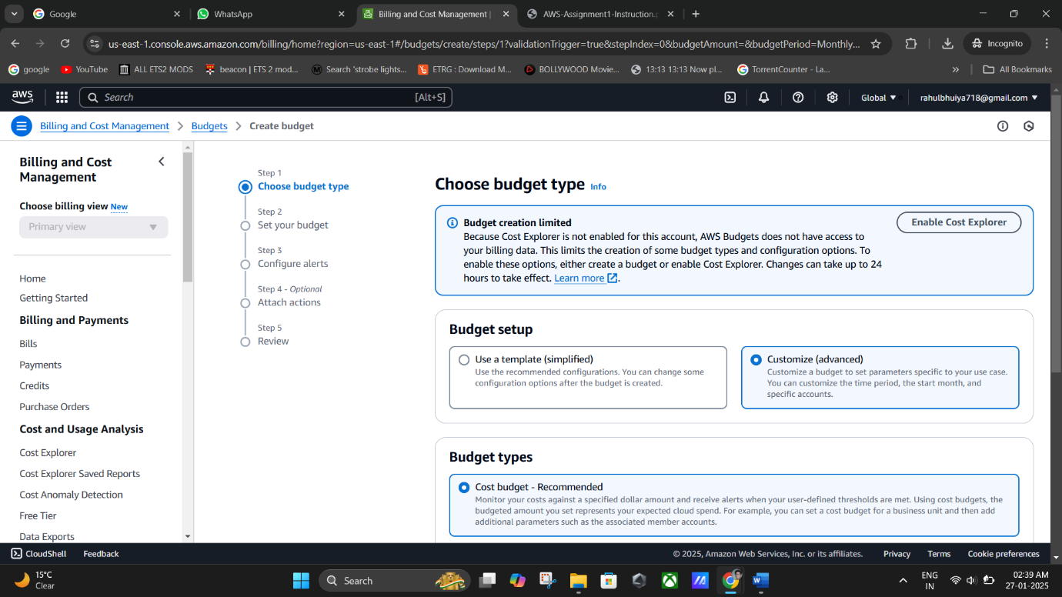

## **Initiate Budget Creation:**

* + Click on **Create Budget** at the top of the Budgets page.

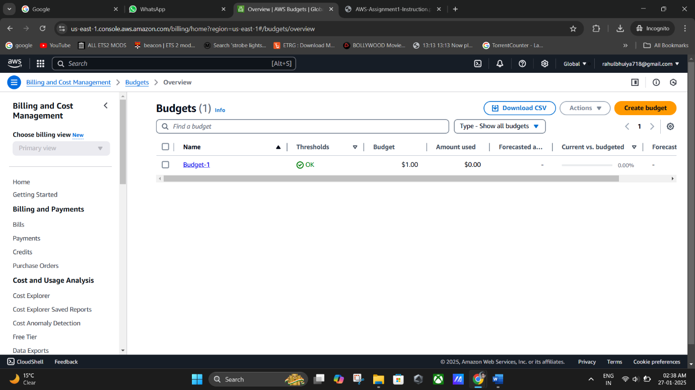

## **Select Budget Type:**

* Under **Budget Setup**, select **Customize (Advanced)**.



* + Choose **Cost Budget** as the budget type, then click **Next**.

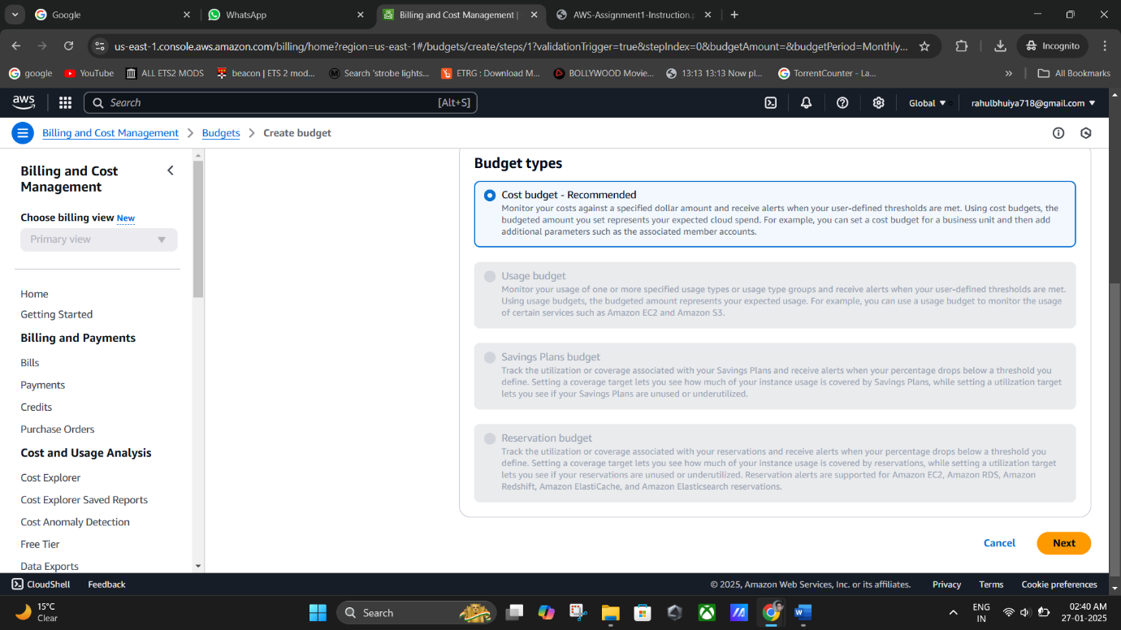

## **Define Budget Details:**

* + Enter a unique **Budget Name** (e.g., "Budget-1").

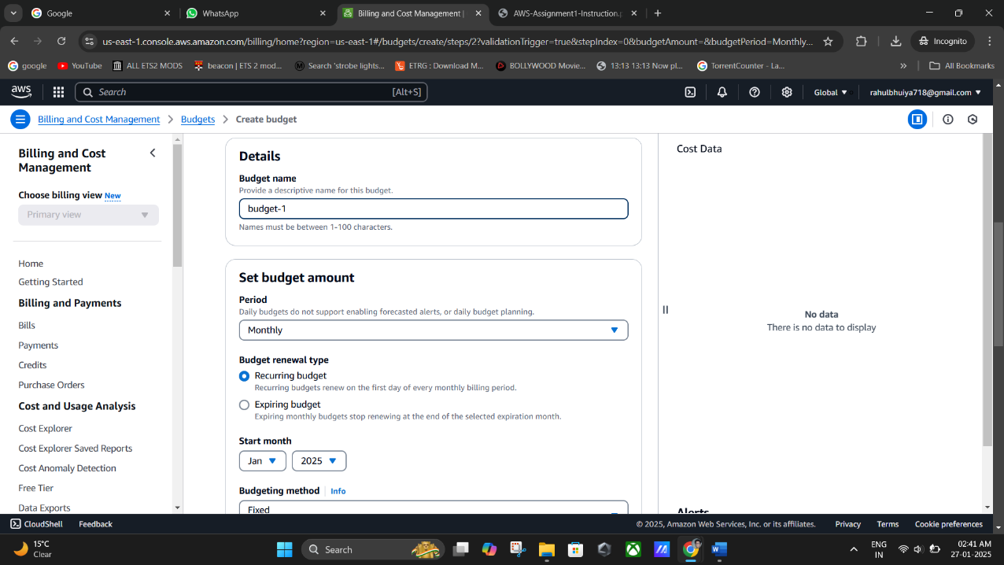

* + Set the budget period to **Monthly** for recurring resets.
  + Choose a **Budget Renewal Type** as **Recurring Budget**.
  + 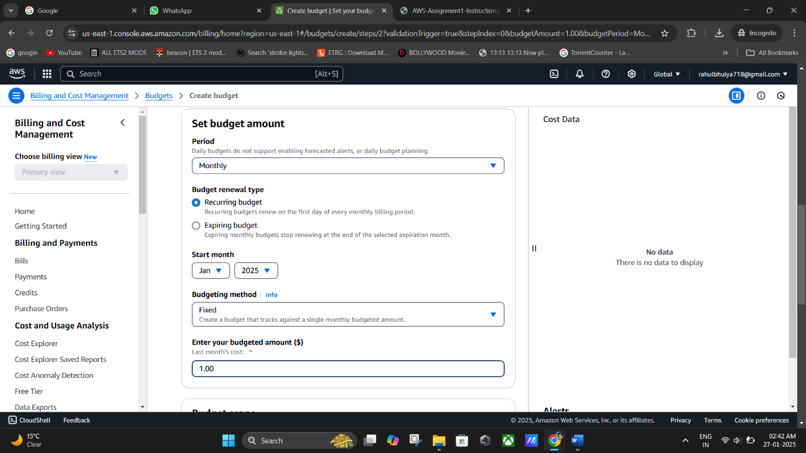Set a **Budgeted Amount** (e.g., $1.00), then click **Next**.

v

## **Set Alerts:**

* + Add an alert threshold to receive notifications.
  + Under **Set Alert Threshold**, choose a percentage threshold (e.g., 80% of the budget).
  + Enter email addresses for notification recipients.

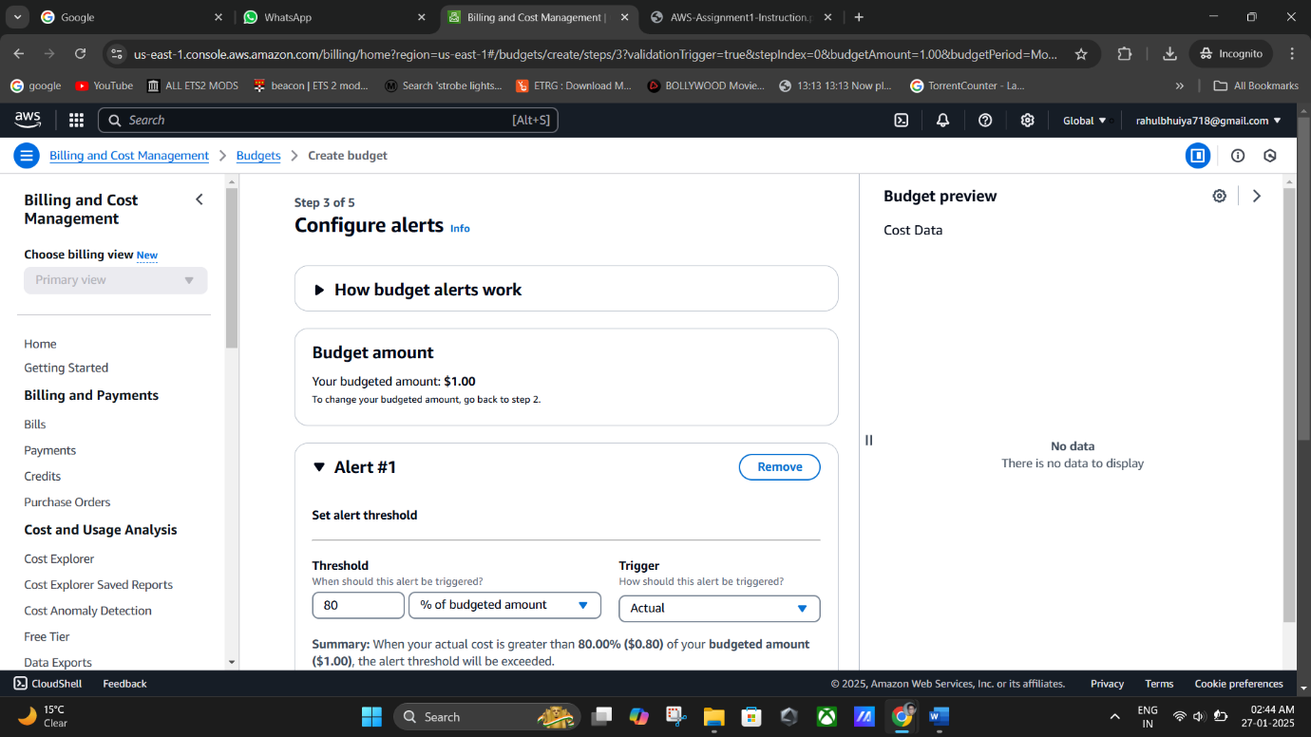

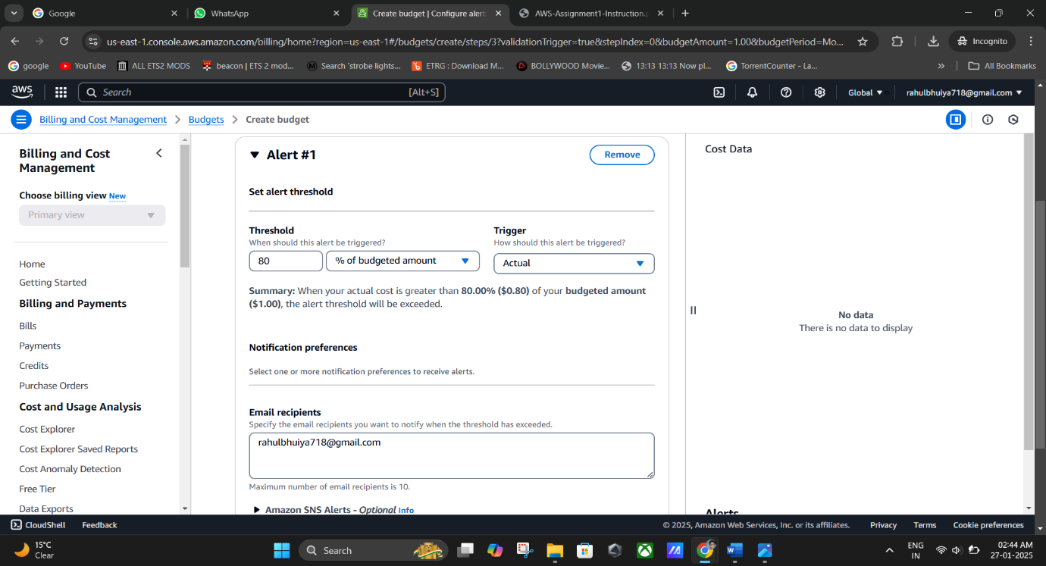

## **Finalize and Review:**

* + Review all budget settings.

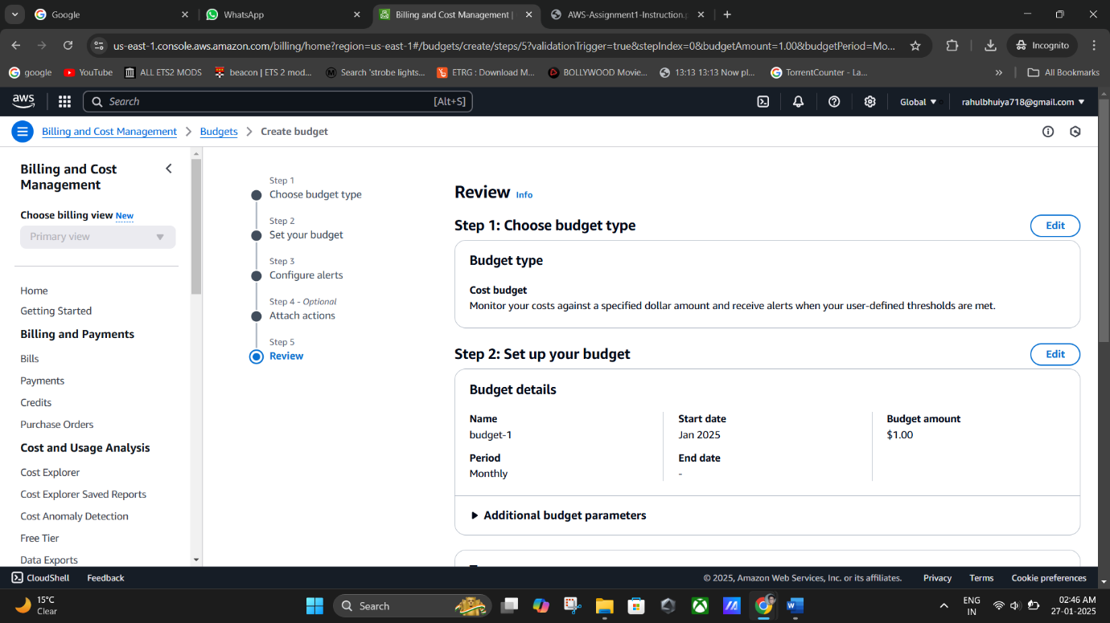

* + 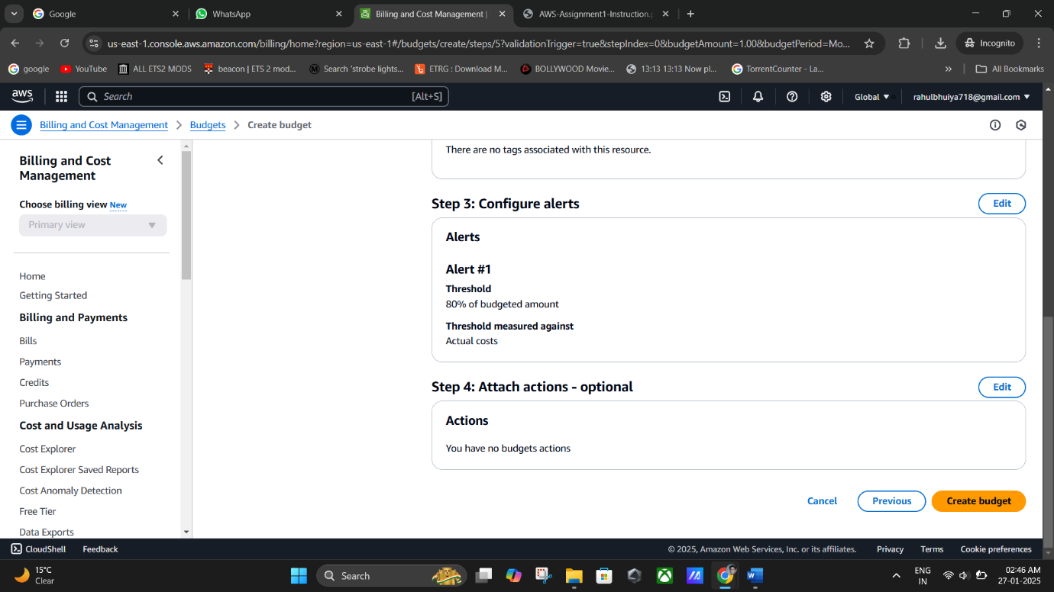Click **Create Budget** to finalize the configuration.

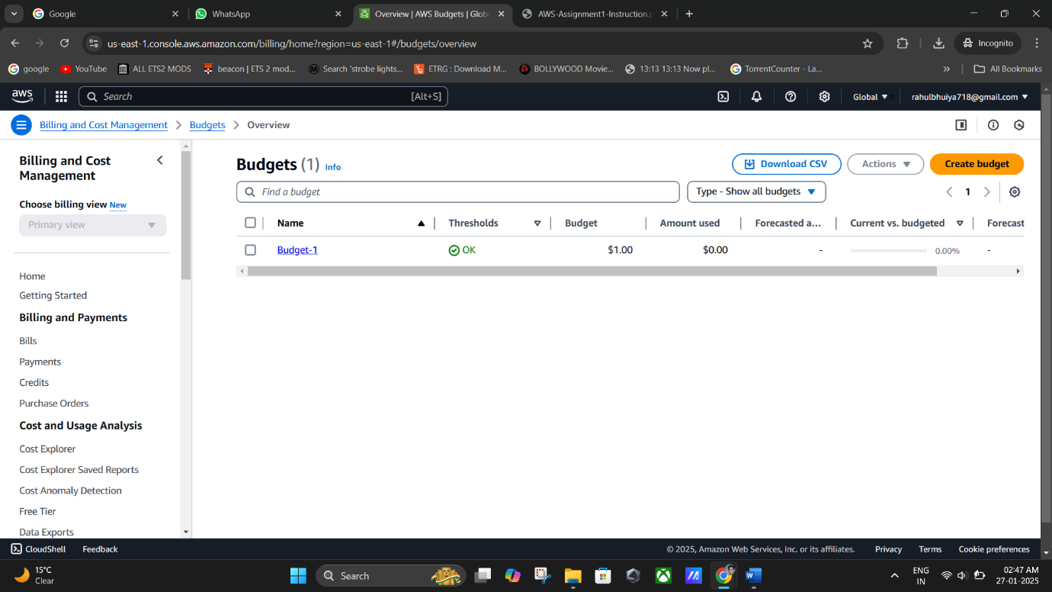

**(Budget-1 Created Successfully).**

## **Remarks:**

* Use descriptive budget names for easier identification.
* Keep alert thresholds realistic to avoid unnecessary notifications.
* Regularly review the **Budgets Overview** section for spending insights.

# **Key Takeaways:**

* Creating an AWS account requires valid payment details and email verification.
* Configuring budgets helps you monitor and control AWS costs effectively.
* Familiarity with the AWS Management Console interface is essential for efficient usage.